Introduction
Welcome to your favorite programming Lab. In this lab manual, we shall work together to learn and implement new programming concepts.

Skills to be learned:
- Distinguish the requirement between the use of conditional and counter loops.
- Divide complex problems into smaller easily solvable sub-problems.

Let's do some coding.

Skill: Distinguish the requirement between the use of conditional and counter loops.

Introduction
By this week, you have learned how to write a program that contains conditional statements, and functions. In this class, we will learn about another very powerful concept known as Loops.
Loops are used to execute a number of instructions repeatedly until a condition is satisfied. Loops can be categorized into two major categories.
- Conditional Loops
- Counter Loops

Conditional Loops
Conditional loops help to repeat a set of instructions until some condition is true. There are two common places for its use.
- Reading an unknown amount of input from the user
- Validating input.

C++ provides a while loop that is used as a conditional loop.
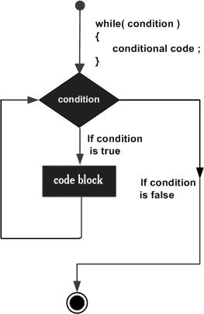

Task 01(WP): Write a program that keeps printing I am happy on the screen until the user enters n.
In this problem, we don’t know in advance how many times the loop will be executed.  But we do know the terminating condition. i.e., when the user will enter n then we will stop the while loop.  In such situations, we use the While loop which is a conditional loop. | 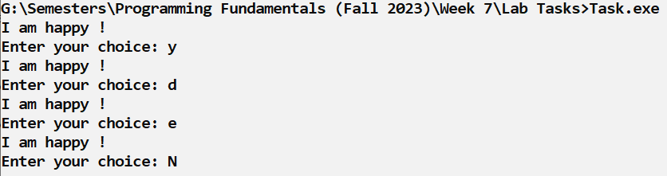
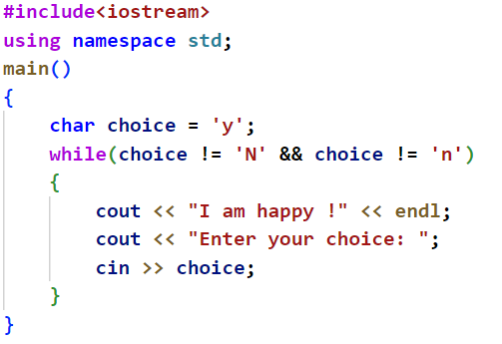 | Consider the attached solution

Great Work Students, You have just learned another skill.

Let's use this skill to solve more complex problems.

Task 02(WP):
Write a Program that keeps asking for inputing a number and adding the sum until the user enters a negative number.
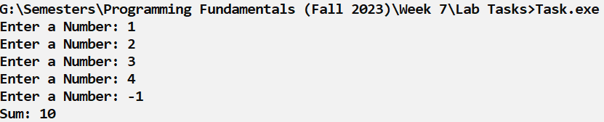 | Observe that the program can not move ahead until the user enters a positive number.
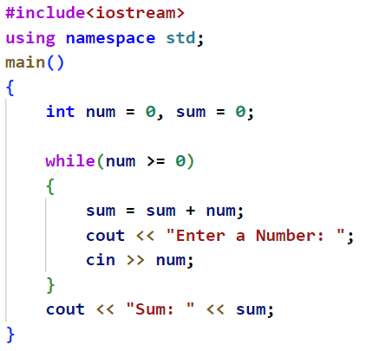 | Consider the attached solution

Counter Loops
The Counter loops are used in situations where the program knows in advance how many times the loop will be executed. The “for” loop is an example of the counter loop.

The for Loop Consists of three major components.
- Initial Statement
- Loop Condition
- Update Statement

Look at the following diagram to understand the flow of the For loop.
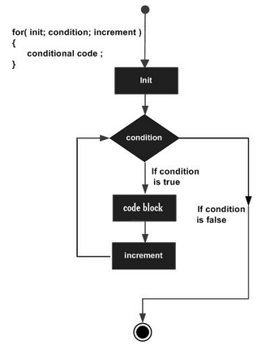
- The loop starts from the initial statement
- Now, every time the condition is True, the loop executes the body and then executes the update statement.
This process is repeated until the condition is evaluated as False.

Consider the following example for better understanding.

Task 03(WP): Write a program that has a function that shows counting from 1 to 10 on the console screen.

Without the loop this program would consist of 10 cout << statements;  However, as we are performing the same task repeatedly and know in advance that we need to perform the task 10 times.  Therefore, we can use the for loop in this situation. | 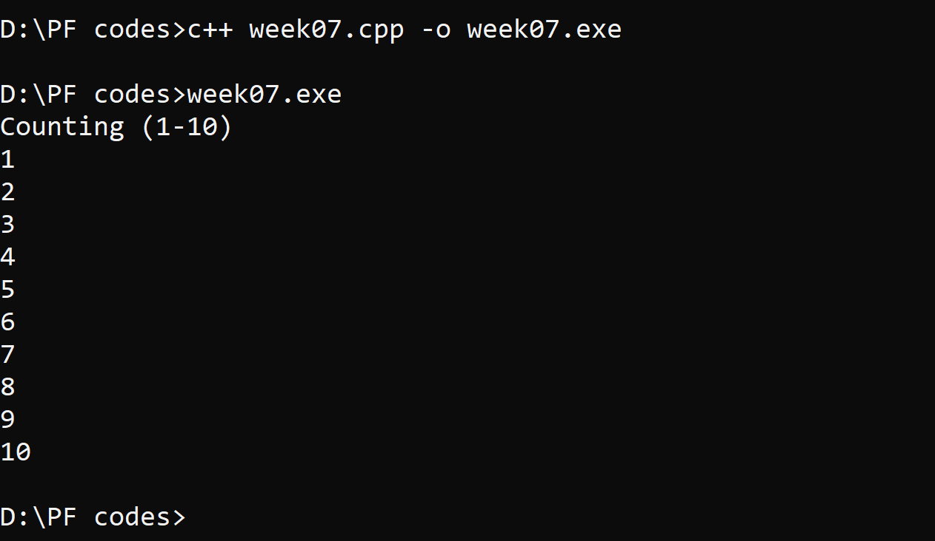
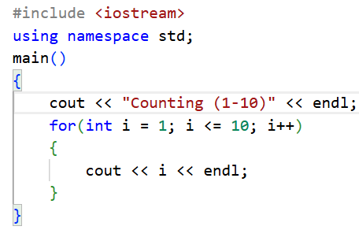 | Consider the attached solution.
The loop will start from the initial statement of i=1 and if the loop condition is true the update statement will increase i by 1 each time the loop body is completed.

Consider the following explanation for better understanding.

Explanation:
Iteration | Variable | i <= 10 | Action (Body of for Loop) | Update Statement
1st | i = 1 | True | 1 is printed. | i is increased to 2.
2nd | i = 2 | True | 2 is printed. | i is increased to 3.
3rd | i = 3 | True | 3 is printed. | i is increased to 4.
4th | i = 4 | True | 4 is printed. | i is increased to 5.
5th | i = 5 | True | 5 is printed. | i is increased to 6.
6th | i = 6 | True | 6 is printed. | i is increased to 7.
7th | i = 7 | True | 7 is printed. | i is increased to 8.
8th | i = 8 | True | 8 is printed. | i is increased to 9.
9th | i = 9 | True | 9 is printed. | i is increased to 10.
10th | i = 10 | True | 10 is printed. | i is increased to 11.
11th | i = 11 | false | The loop is terminated

Great Work Students, You have just learned another skill.
Let's use this skill to solve more complex problems.

Task 04(WP): Calculate the sum of the first 5 natural numbers.
Consider the above-mentioned question and think about how we can do this by using the loop. 💡 | 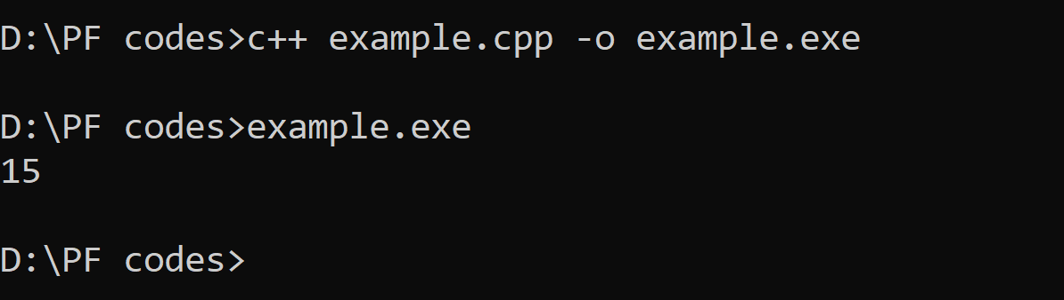
In such problems, we can divide the problem into sub-problems. For example, consider the previous working problem example where we printed the first ten natural numbers on the screen.
Now, what if we can store the number in some variable and add the next number in the previously stored variable after each update statement?

Consider the following solution for better understanding.
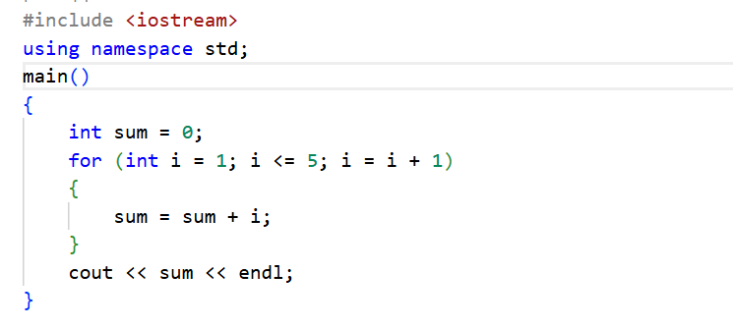

Similarly, we can perform similar complex tasks with repetitive structures using the for loop.

Task 05(OP):
Write a program to calculate the sum of the first 100 natural numbers.

It's your Choice 💡
Both Loops, may it be a Conditional Loop or a Counter Loop can be used for solving the same problems. However, it is up to YOU to choose the best suitable option.

Solution with Conditional Loop | Solution with Counter Loop
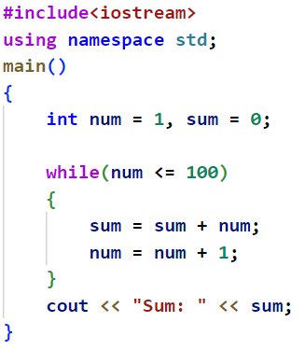 | 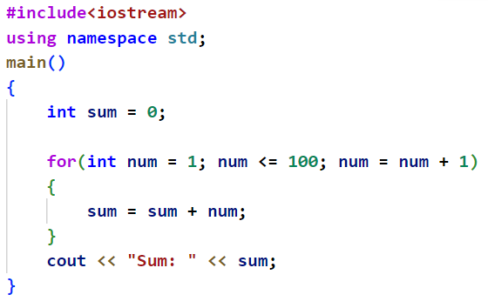
Note: It is better to use For loop when we already know how many times the loop has to be executed (We can place the initialization statement, loop condition and increment statement in a single line).
It is better to use the While loop when you have to keep repeating something until some condition is met.

Now before moving towards solving the complex real world problems, it's important that we dry run the while and for loops so that we get a deep understanding of how the loops are working.
What will be the Output of following code snippets?

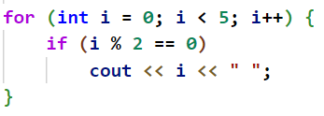 | 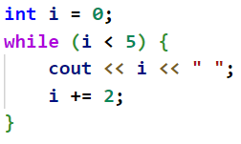 | 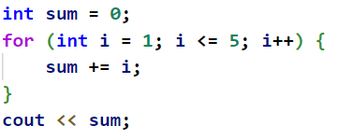
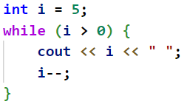 | 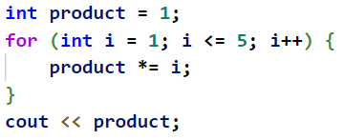 | 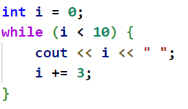
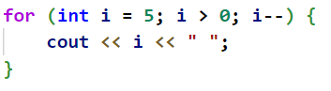 | 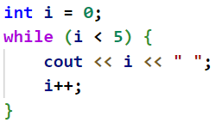 | 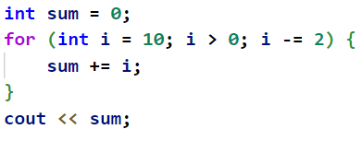

Conclusion
Conditional Loop | We use Conditional Loops in programs where we do not know in advance how many times the loop will be executed. While Loop is an example of a Conditional Loop.
Counter Loops | We use Counter Loops in programs where we know in advance how many times the loop will be executed. For Loop is an example of a Counter Loop.

Task 01(CP): (printTable)
Write a program that takes a number from the user and print its multiplication table on the console screen. | 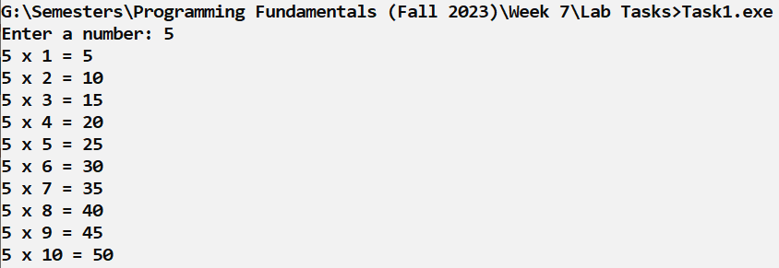

Task 02(CP): (generateFibonacci)
Write a program that prompts the user to input the length of Fibonacci series and then call the function to display the series.  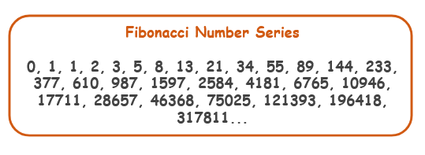 | 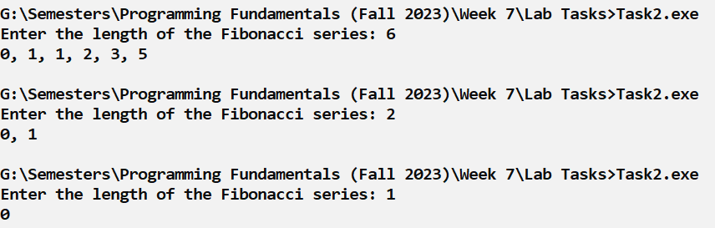

Task 03(CP): (totalDigits)
Write a program named “totalDigits” that takes the number as input parameter and returns the total number of digits in that number. | 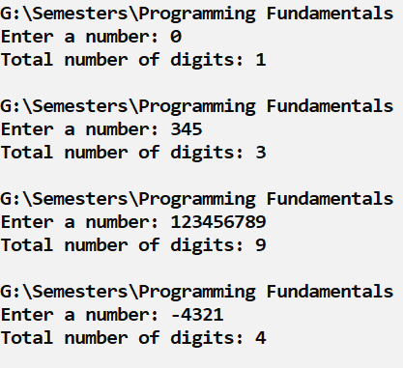

Task 04(CP): (frequencyChecker)
Find the frequency of a digit in a number.  First Enter the number. Then Enter the Digit to find Frequency of that Number.  Test Cases:  frequencyChecker(566960, 6) => 3  frequencyChecker(566960, 5) => 1 | 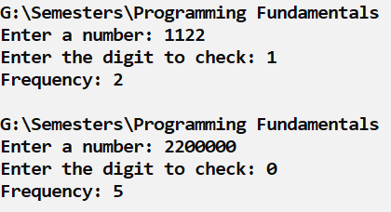

Task 05(CP): (digitSum)
Write a program that takes a number from the user and prints the sum of its digits on the console screen. | 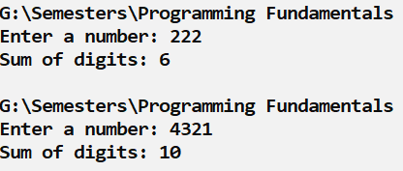

Task 06(CP): (GCD/LCM)
Write a program to find the greatest common divisor (GCD) and Least Common Multiple (LCM) of the given two numbers.  The Greatest Common Divisor (GCD) or Highest Common Factor (HCF) of two positive integers is the largest positive integer that divides both numbers without a remainder.  The Least Common Multiple (LCM) of two integers is the smallest integer that is a multiple of both numbers.  Hint:  LCM(a, b) = (a * b) / GCD(a, b) | 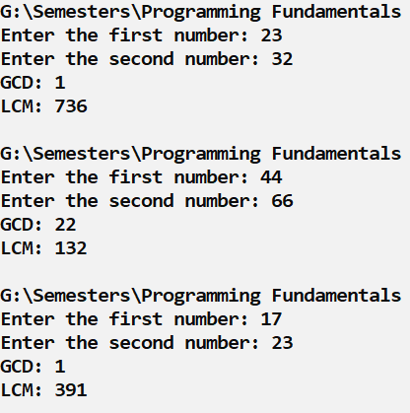

Task 07(CP): (Percentage)
We have n integer numbers within the range of [1 … 1000]. Some percent of p1 are under 200, another percent p2 are from 200 to 399, percent p3 are from 400 to 599, percent p4 are from 600 to 799 and the rest p5 percent are from 800 upwards. Write a program that calculates and prints the percentages p1, p2, p3, p4 and p5.

Example: we have n = 20 numbers: 53, 7, 56, 180, 450, 920, 12, 7, 150, 250, 680, 2, 600, 200, 800, 799, 199, 46, 128, 65. We get the following distribution and visualization:
Input Data:
On the first line of the input there is an integer n (1 ≤ n ≤ 1000) that represents the count of lines of numbers that will be passed. On each of the following n lines we have one integer within range of [1 … 1000] – numbers, on which we have to calculate the histogram.
Output Data:
Print on the console a histogram that consists of 5 lines, each of them containing a number within the range of [0% … 100%], formatted up to two digits after the decimal point (for example 25.00%, 66.67%, 57.14%).

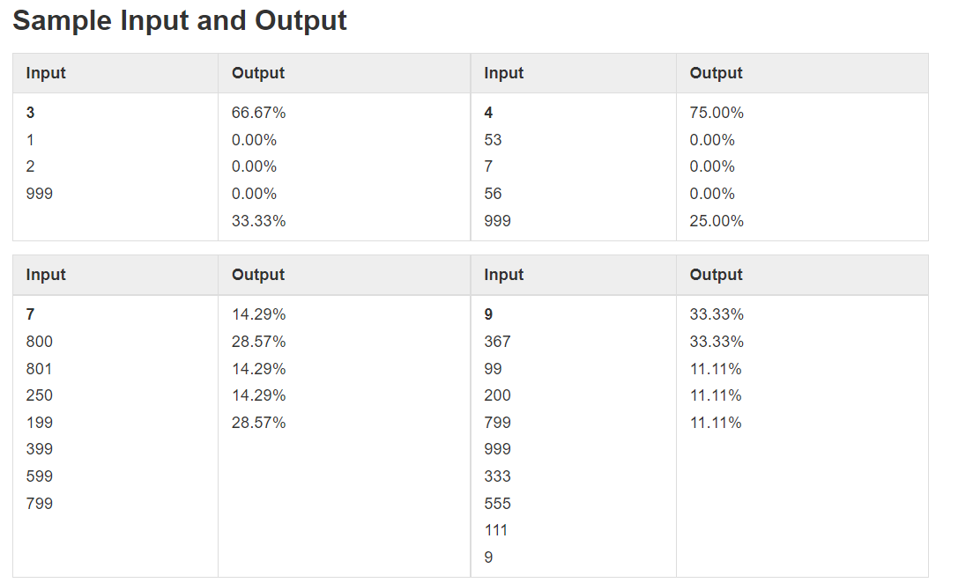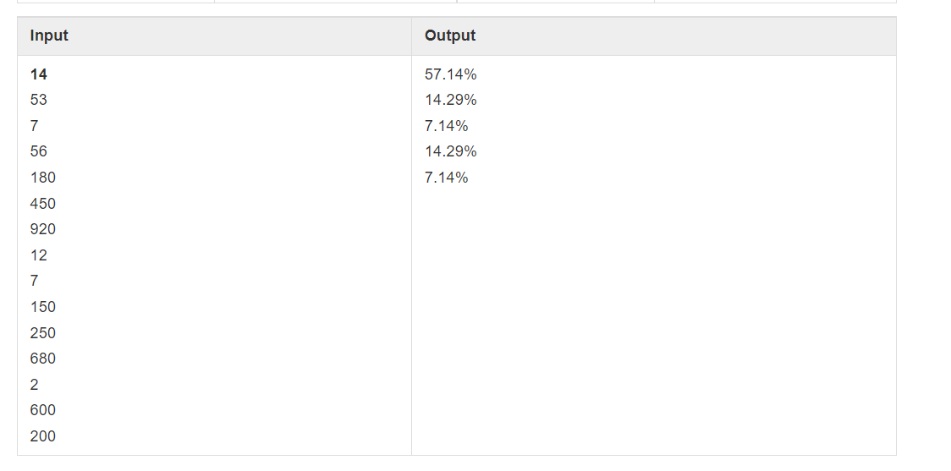

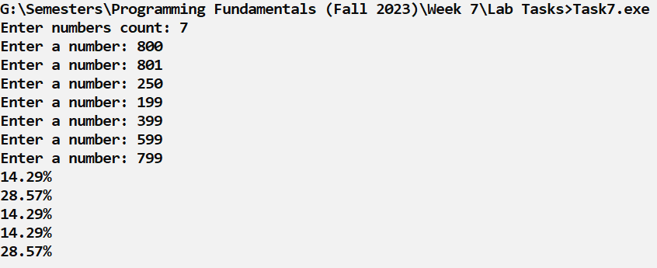

Task 08(CP): (Lilly)
Lilly is N years old. For each birthday she receives a present. For each odd birthday (1, 3, 5, …, n) she receives toys, and for each even birthday (2, 4, 6, …, n) she receives money. For her second birthday she received 10.00 USD, and the amount is increased by 10.00 USD for each following even birthday (2 -> 10, 4 -> 20, 6 -> 30 etc.). Over the years Lilly has secretly saved her money. Lilly's brother, in the years when she received money, took 1.00 USD from each of the amounts. Lilly has sold the toys, received over the years, each one for P USD and added the sum to the amount of saved money. With the money she wanted to buy a washing machine for X USD.
Write a program that calculates how much money she has saved and if it is enough to buy a washing machine.
Input Data
We read from the console 3 numbers, each on a separate line:
- Lilly's age – integer in the range of [1 … 77].
- Price of the washing machine – integer number in the range of [1 … 10 000].
- Unit price of each toy – integer in the range of [0 … 40].
Output Data
Print on the console one single line:
- If Lilly's money is enough:
- “Yes! {N}” – where N is the remaining money after the purchase
- If the money is not enough:
- “No! {M}” – where M is the insufficiency amount
Sample Output:
Input | Output
10  170  6 | Yes!  5
21  1570  3 | No!  1000

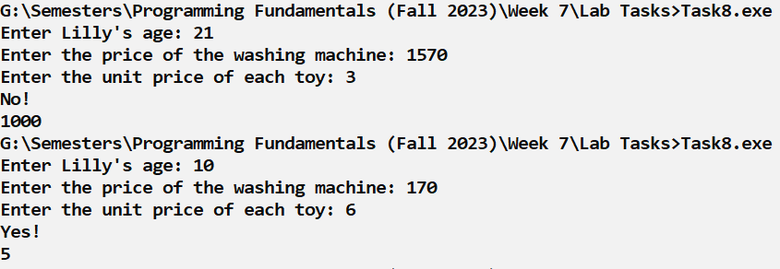

Task 09(CP): (Ivan)
Ivan is 18 years old and receives an inheritance that consists of X money and a time machine. He decides to return to 1800, but does not know if the money will be enough to live without working. Write a program that calculates if Ivan will have enough money to not have to work until a particular year (inclusive). Assuming that for every even (1800, 1802, etc. )year he will spend 12000 dollars. For every odd one (1801, 1803, etc.) he will spend 12000 + 50 * [the age he will have reached in the given year].
Input Data
The input is read from the console and contains exactly 2 lines:
- Inherited money – integer number in the range [1 … 1 000 000.].
- Year, until which he has to live in the past (inclusive) – integer number in the range [1801 … 1900].
Output Data
Print on the console 1 line. The sum must be formatted up to the two symbols after the decimal point:
- If money is enough:
  - "Yes! He will live a carefree life and will have {N} dollars left." – where N is the money that will remain.
- If money is NOT enough:
  - "He will need {М} dollars to survive." – where M is the sum that is NOT enough.
Sample Output:
Input | Output
50000  1802 | Yes! He will live a carefree life and will have 13050 dollars left.
100000  1808 | He will need 12400 dollars to survive.

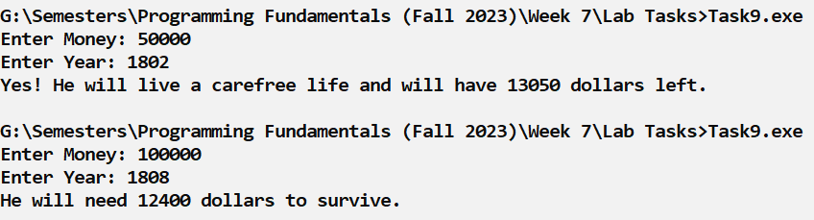

Understanding the while(true) Loop:
In programming, while(true) is used to create an infinite loop, which means the loop keeps running continuously without stopping on its own. The condition true is always correct, so the program will keep repeating the statements inside the loop again and again. This type of loop is commonly used in menu-driven programs, such as ATM systems, calculators, or business applications, where we want the program to keep showing the menu until the user decides to exit. To stop a while(true) loop, programmers usually use a break statement inside the loop when a specific condition is met (for example, when the user selects the “Exit” option). In simple words, while(true) allows the program to run continuously and respond to user choices until the user tells the program to stop.

Example # 1:
Write a C++ program that demonstrates the use of the while(true) loop in a simple menu-driven application.
The program should display a menu with the following options:
- Say Hello – Display the message "Hello! Welcome to the program."
- Say Goodbye – Display the message "Goodbye! Have a nice day."
- Exit – Terminate the program
#include <iostream>
using namespace std;
int main() {
while (true) {
int choice;

cout << "\n===== MENU =====" << endl;
cout << "1. Say Hello" << endl;
cout << "2. Say Goodbye" << endl;
cout << "3. Exit" << endl;
cout << "Enter your choice: ";
cin >> choice;

if (choice == 1) {
cout << "Hello! Welcome to the program." << endl;
}
else if (choice == 2) {
cout << "Goodbye! Have a nice day." << endl;
}
else if (choice == 3) {
cout << "Program ended." << endl;
break;
}
else {
cout << "Invalid choice!" << endl;
}
}

return 0;
}

Task 10(CP): (Bussiness Menu)
Problem Statement (Restaurant Management System)
Write a C++ program to simulate a simple Restaurant Management System using a menu-driven approach.
The program should display a menu with the following options:
- View Food Menu – Display the message "You selected: View Food Menu."
- Place Order – Display the message "You selected: Place Order."
- View Order Status – Display the message "You selected: View Order Status."
- Generate Bill – Display the message "You selected: Generate Bill."
- Contact Staff – Display the message "You selected: Contact Staff."
- Exit – Exit the program with the message "Exiting Restaurant Management System. Thank you!"
Test Case:
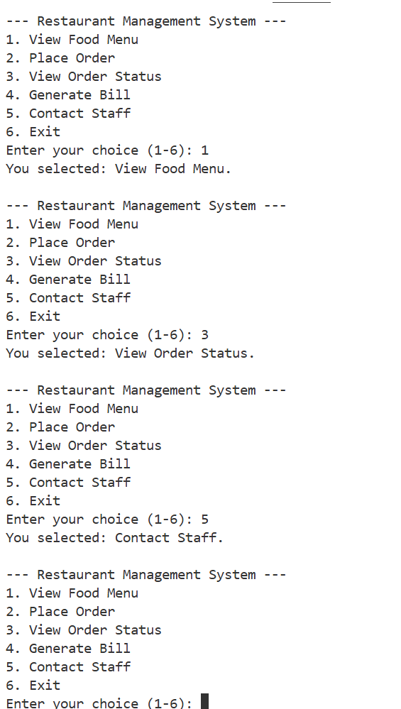

Task 11(CP): (Calculator)
Write a C++ program to simulate a Simple Calculator using a menu-driven approach that take two input number.
The program should display the following menu:
- Addition –display their sum.
- Subtraction –display their difference.
- Multiplication –display their product.
- Division –display the result of division. Handle division by zero.
- Clear Screen – Display a message "Screen cleared." (Optional: clear console if your system allows).
- Exit – Exit the program with the message "Exiting Calculator. Goodbye!"
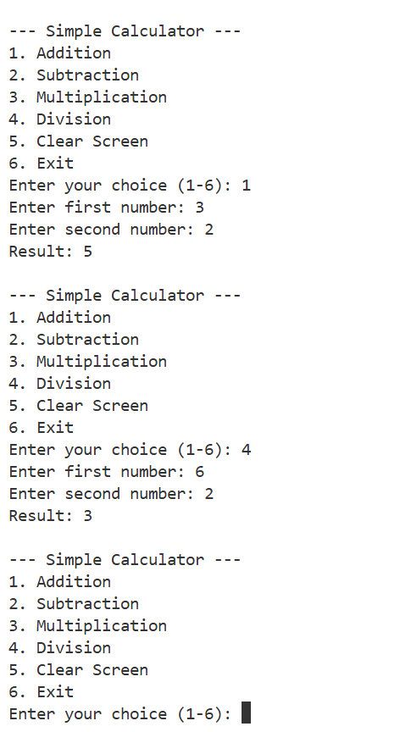

Task 12(CP): (Library System)
Write a C++ Program To stimulate a Library System using a Menu-Driven Approach.
The program should display the following menu:
1.Add Books
2.View Books
3.Borrow Books
4.View Books
5.Exit
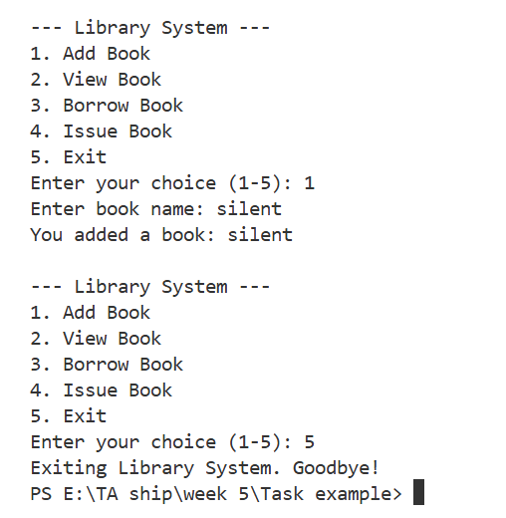

Nested Loop

A nested loop is a loop placed inside another loop. The outer loop runs first, and for each iteration of the outer loop, the inner loop runs completely

Task 13(CP):(Shaped-Box)
Write a C++ program using nested loops to print a 3×3 star (*) pattern.i.e:
* * *
* * *
* * *
Task 14(CP):
Write a C++ program to print a right-angled triangle of stars like this using Nested Loop:
*
* *
* * *
* * * *
* * * * *
Task 15(CP):
Write a C++ program to print a square of numbers (3×3) like this using Nested Loop:

1 2 3
1 2 3
1 2 3
Task 16(CP):
Write a C++ program to print numbers in reverse order in a triangle like this using Nested Loop:
5
5 4
5 4 3
5 4 3 2
5 4 3 2 1

Good Luck and Best Wishes!!
Happy Coding ahead :)

